
GIS Library Tutorials - Introduction to ArcGIS Online - 1

ArcGIS Online

Getting Started & Overview

ArcGIS Online is a collaborative web GIS that allows you to use, create, and share maps, scenes, apps, layers, analytics, and data.
https://doc.arcgis.com/en/arcgis-online/reference/faq.htm#anchor1

To sign into ArcGIS Online click on this link: https://ucdireland.maps.arcgis.com

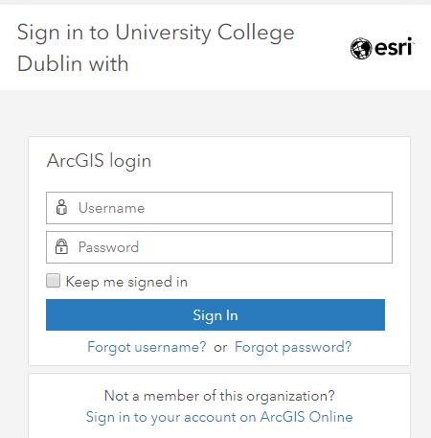
Type in your Username and Password and left click on Sign In

Your Username will need to be set up by IT Services in UCD

To get a username, submit a request via the Get Help link on UCD's IT Support Hub page https://fujitsuireland.service-now.com/itucd

In order to complete the following exercises, you will need to ensure you have been assigned, at a minimum, the user type ‘Creator’. See information here:

https://doc.arcgis.com/en/arcgis-online/reference/roles.htm#USER_TYPES

To publish maps which you have created you will need to have been assigned the role ‘Publisher’.

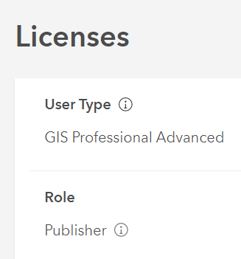
The following exercises were created with -

User Type: GIS Professional Advanced
and Role: Publisher

From the home page left click on the Map tab

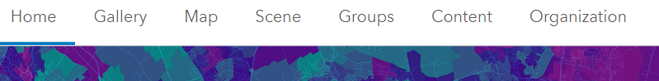


Left click on Open in Map Viewer Classic

Your screen should have menu on the left and a map in the viewing area (this should show country / area where you are located)

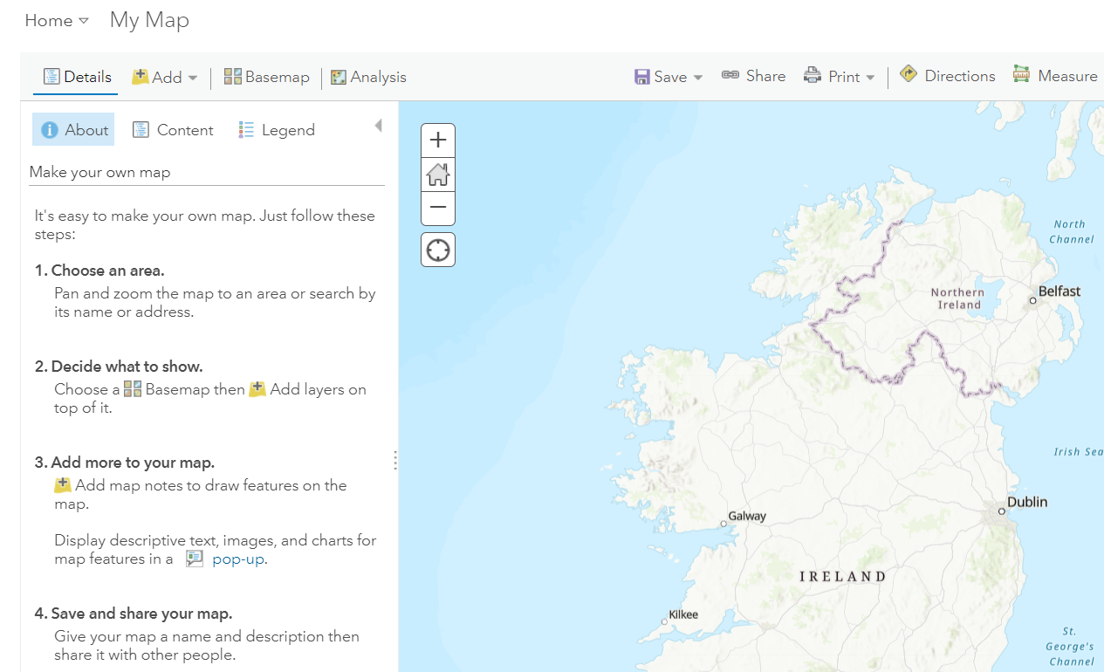

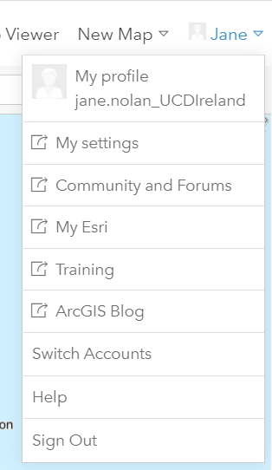
In the top right of the screen, you should see your own name with a small down arrow next to it

Left click on the down arrow to open a menu – this has your settings, the link to Help, and clickable link to Sign Out

